DCRC Nomination Questions
BoviSync Offload Instructions
Custom Reports
(Copy and paste the PDF link into your browser. The PDF format allows you to click on the links and load the reports. Hold down the “ctrl” key (bottom left corner of keyboard) and click on each report link.)

Farm Data
For all cows calving in the time period of January 1 to December 31 for the year prior to the nominating year. All nomination questions are blue colored.

Average herd size (dry and lactating cows)?

Load report to answer the following question (hold “cntrl” key and click the link or copy & paste into your browser)

Herd Size - https://bovisync.farm/report/4KA9ZS

Please fill in the spreadsheet “DCRC_Herd Size” to find the average herd size for the year. In the report, start with the first of the year and record the values for Milking and Dry. Then, change all three dates to the last date of the month and record the values for Milking and Dry. Change all three dates to the last date of the month for the remaining 11 months and record the values for Milking and Dry. When the spreadsheet is filled in, the averages should calculate for Milking and Dry.

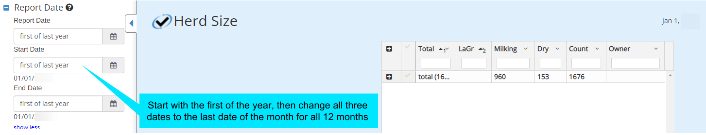

Double-click spreadsheet icon to open spreadsheet

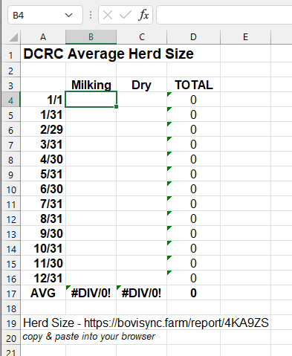

Breeds and Do over 25% of the cows in the herd have a non-Holstein parent?

Load report to answer the following question (click the link or copy & paste into your browser)

Breeds of Cows - https://bovisync.farm/report/AE95KO

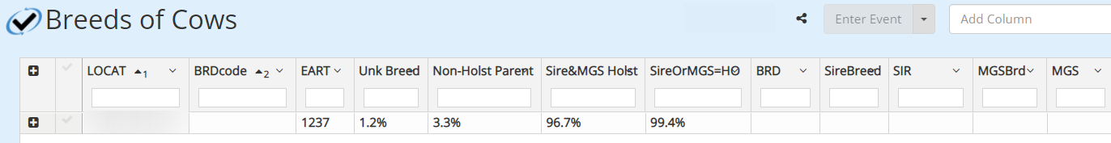

Percent of herd that is first lactation cows?
Voluntary breeding wait policy?
Average calving interval (in days)?
Average days to first breeding?
Percent of pregnant cows pregnant by 150 DIM?
Percent of the herd that is greater than 300 DIM and open?

Load report to answer the following questions (click the link or copy & paste into your browser)

DCRC Animal Summary Report - https://bovisync.farm/report/ISBBJA

Average 21-day pregnancy rate?
High 21-day pregnancy rate?
Month high 21-day pregnancy rate was achieved?
Low 21-day pregnancy rate?
Month low 21-day pregnancy rate was achieved?

Load report to answer the following questions (click the link or copy & paste into your browser)

Breeding Intensity https://bovisync.farm/breeding_intensity/?start_date=first+of+last+year&end_date=end+of+last+year&window=21&abort_min=35&report_type=Table&lactation=1_50&grplist=

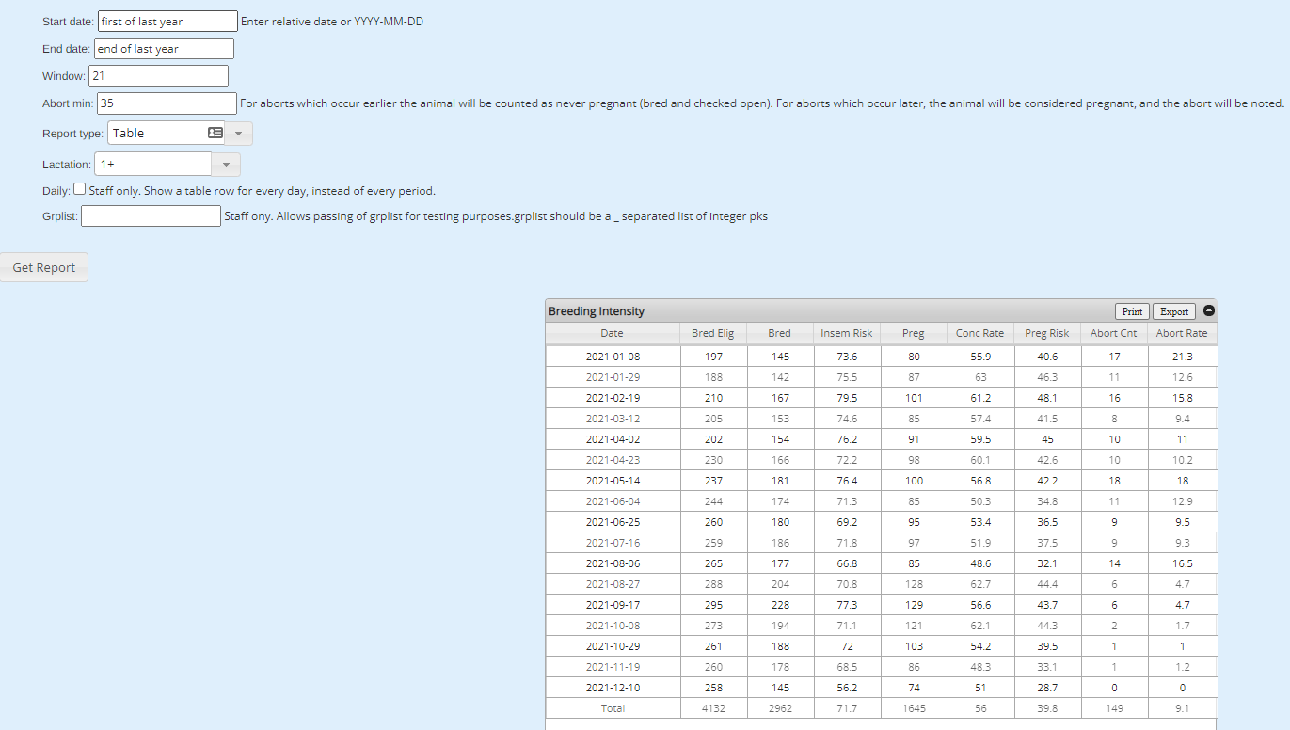

How many cows left the herd during the time period (all reasons)?
Of the total number of cows that left the herd, how many left because of reproductive reasons?

Load report to answer the following questions (click the link or copy & paste into your browser)

Reasons for Cows Leaving Herd - https://bovisync.farm/report/NL33IJ

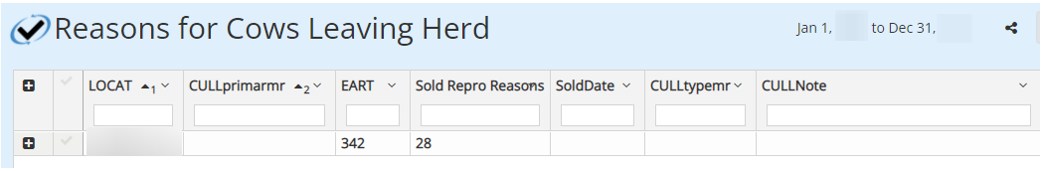

RepMon file in BoviSync

REPMON - https://bovisync.farm/report/ENLXBJ

Repmon_Export (copy & paste link below into your browser)
https://bovisync.farm/reports/?end_date=end+of+last+year&output_type=Table&threshold=&col_1=EART&threshold_1=&axis_1=x-axis&aggreg_type_1=%25+above&aggreg_val_1=&plot_style_1=Points&col_2=BDATE&threshold_2=&axis_2=y-axis&aggreg_type_2=%25+above&aggreg_val_2=&plot_style_2=Points&col_3=LACT&threshold_3=&axis_3=y-axis&aggreg_type_3=%25+above&aggreg_val_3=&plot_style_3=Points&col_4=FDAT&threshold_4=&axis_4=y-axis&aggreg_type_4=%25+above&aggreg_val_4=&plot_style_4=Points&col_5=TiBRD&threshold_5=&axis_5=y-axis&aggreg_type_5=%25+above&aggreg_val_5=&plot_style_5=Points&col_6=1BrDt&threshold_6=&axis_6=y-axis&aggreg_type_6=%25+above&aggreg_val_6=&plot_style_6=Points&col_7=2BrDt&threshold_7=&axis_7=y-axis&aggreg_type_7=%25+above&aggreg_val_7=&plot_style_7=Points&col_8=3BrDt&threshold_8=&axis_8=y-axis&aggreg_type_8=%25+above&aggreg_val_8=&plot_style_8=Points&col_9=4BrDt&threshold_9=&axis_9=y-axis&aggreg_type_9=%25+above&aggreg_val_9=&plot_style_9=Points&col_10=5BrDt&threshold_10=&axis_10=y-axis&aggreg_type_10=%25+above&aggreg_val_10=&plot_style_10=Points&col_11=5BrDt&threshold_11=&axis_11=y-axis&aggreg_type_11=%25+above&aggreg_val_11=&plot_style_11=Points&col_12=5BrDt&threshold_12=&axis_12=y-axis&aggreg_type_12=%25+above&aggreg_val_12=&plot_style_12=Points&col_13=BREDDate&threshold_13=&axis_13=y-axis&aggreg_type_13=%25+above&aggreg_val_13=&plot_style_13=Points&col_14=AGEMO&threshold_14=&axis_14=y-axis&aggreg_type_14=%25+above&aggreg_val_14=&plot_style_14=Points&col_15=Repro&threshold_15=&axis_15=y-axis&aggreg_type_15=%25+above&aggreg_val_15=&plot_style_15=Points&col_16=CINT&threshold_16=&axis_16=y-axis&aggreg_type_16=%25+above&aggreg_val_16=&plot_style_16=Points&col_17=PTBRD&threshold_17=&axis_17=y-axis&aggreg_type_17=%25+above&aggreg_val_17=&plot_style_17=Points&col_18=CULLDate&threshold_18=&axis_18=y-axis&aggreg_type_18=%25+above&aggreg_val_18=&plot_style_18=Points&col_19=BV_ME305&threshold_19=&axis_19=y-axis&aggreg_type_19=%25+above&aggreg_val_19=&plot_style_19=Points&col_20=DCAR&threshold_20=&axis_20=y-axis&aggreg_type_20=%25+above&aggreg_val_20=&plot_style_20=Points&filter_item_1=CULLDate&filter_method_1=not+less+than&filter_variable_1=1+year+ago&and_or_2=or&filter_item_2=Repro&filter_method_2=does+not+contain+any+of&filter_variable_2=sold&Cows=Cows&Heifers=Heifers&status=Dead&date_handling=Date&sort_1=-&sort_direction_1=asc&sort_2=-&sort_direction_2=asc&title=Repmon_Export

